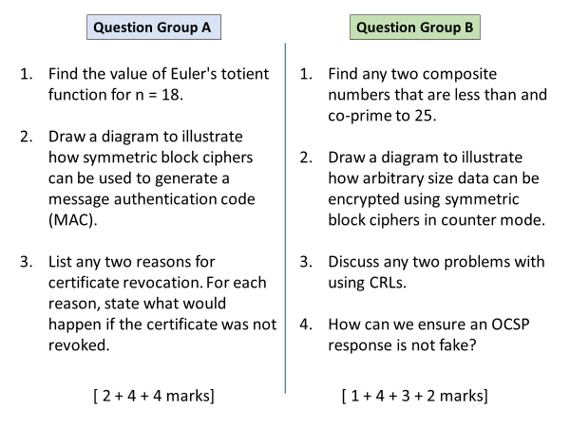
Group A
Q1
Phi(18) = 6
Q2
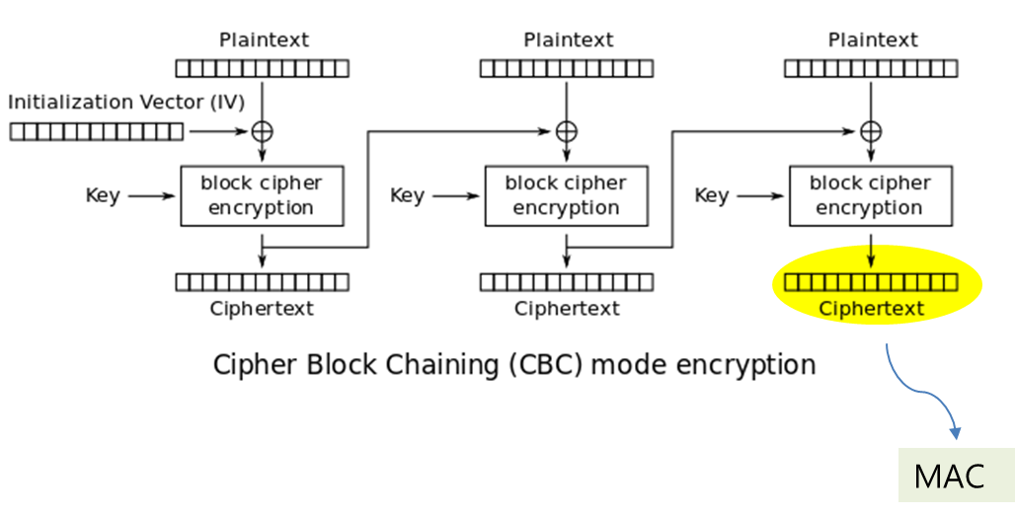
Q3
Any two
Reason | Outcome of non-revocation
Client’s private key compromised | Attacker can pretend to be the client
Staff member on leave, or left the company | Staff member can still represent the company
Subject details changed | Certificate will be no longer useful for subject
CA’s private key compromised | Attacker can issue fake certificates to themselves
Subject provided false information | Users will keep on trusting deceptive subject

Group B
Q1
Any two from: 4, 6, 8, 12, 14, 16, 18, 21, 22, 24
Q2
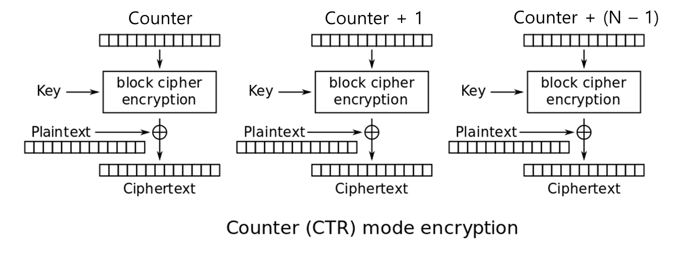
Q3
Heavy traffic load on the Internet bcoz every client needs to download it regularly
CRLs become outdated very quickly and do not hold information of most recently revoked certificates.

Q4
OCSP response mush be signed by the OSCP responder (server). 1 mark
The responder must present their certificate from CA to prove their identity. 1 mark

